Create table with the given structures and insert sample data as specified
A)Table name – SALESPEOPLE
Snum int(4) , Sname varchar(10) , City varchar(10) , Comm float(3,2)
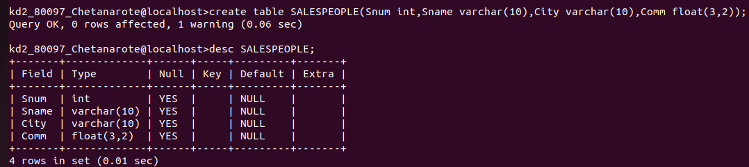
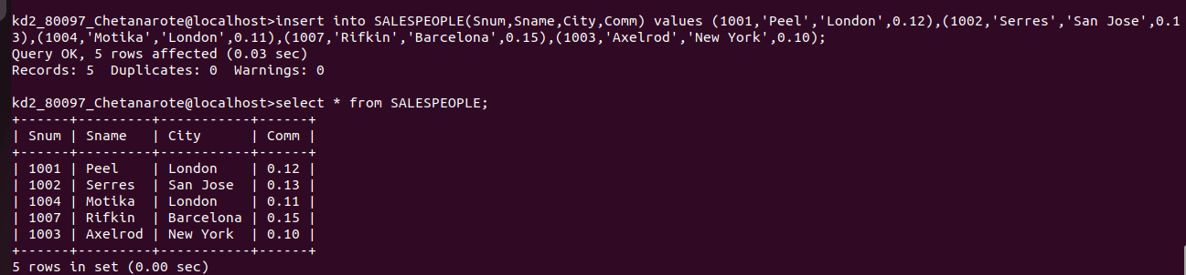

B) Table Name – CUSTOMERS
Cnum int(4) , Cname varchar(10) , City varchar(10) , Rating int(4) , Snum int(4)
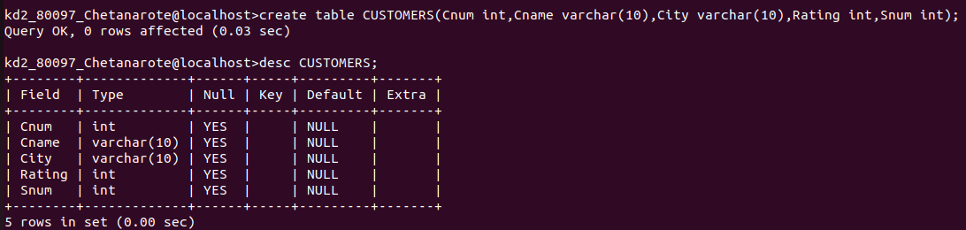
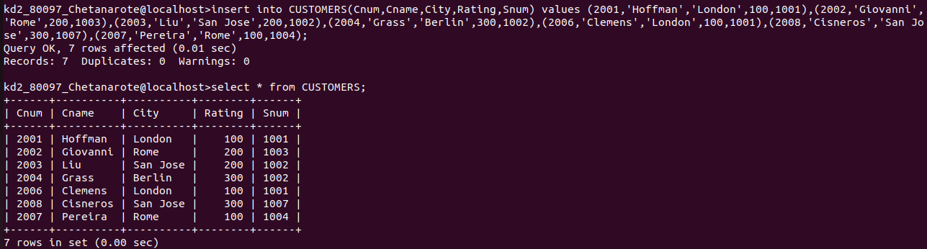
C) Table Name – ORDERS
Onum int(4) , Amt float (7,2) , Odate date , Cnum int(4) , Snum int (4)

